1. **Write a for loop to print the numbers from 1 to 20.  
   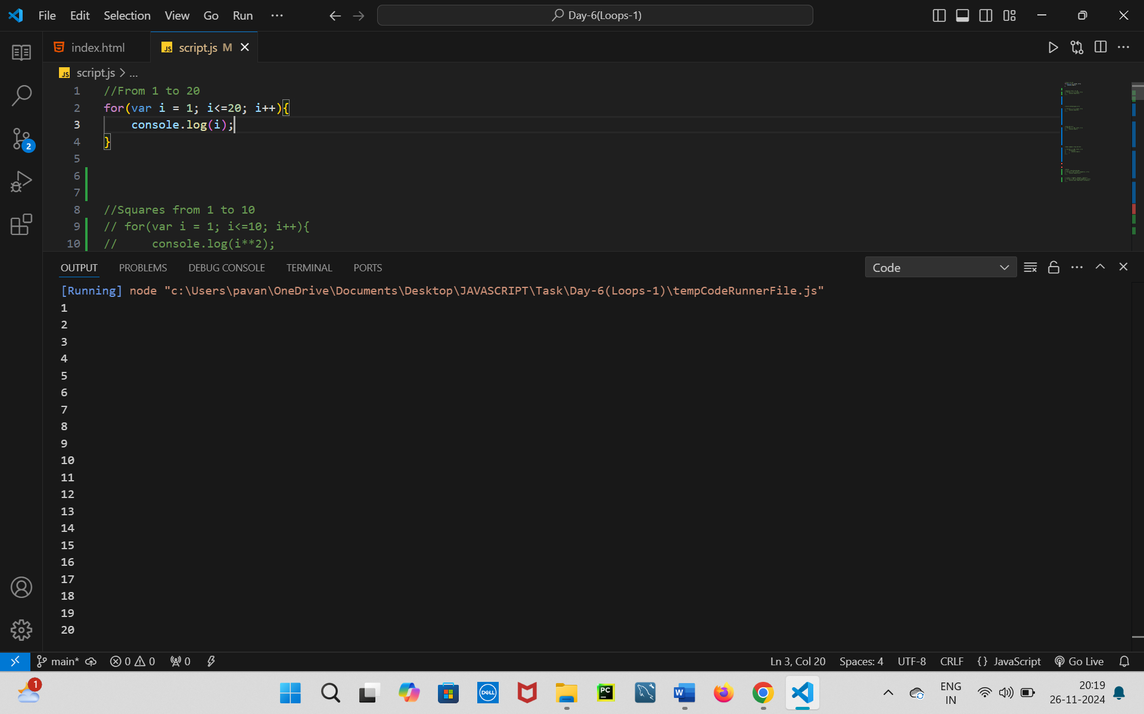**
2. **Create a for loop to print the squares of numbers from 1 to 10.**

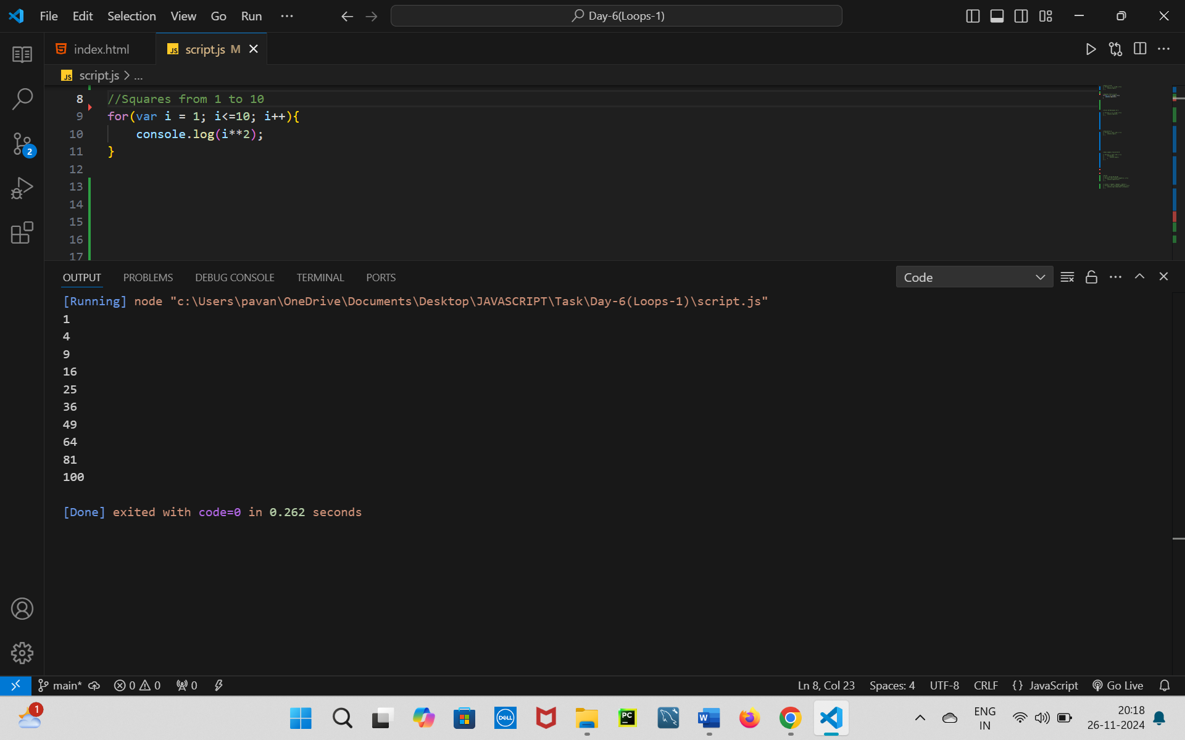

1. **Use a for loop to print the first 10 multiples of 5.**

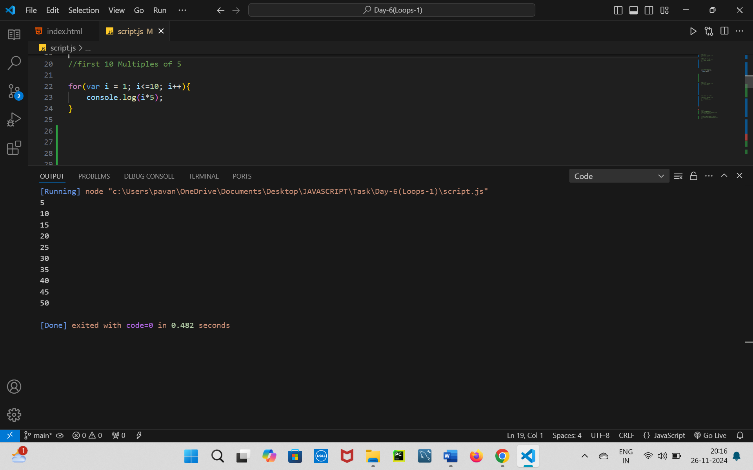

1. **Write a for loop to print numbers from 20 to 1 in reverse order.**

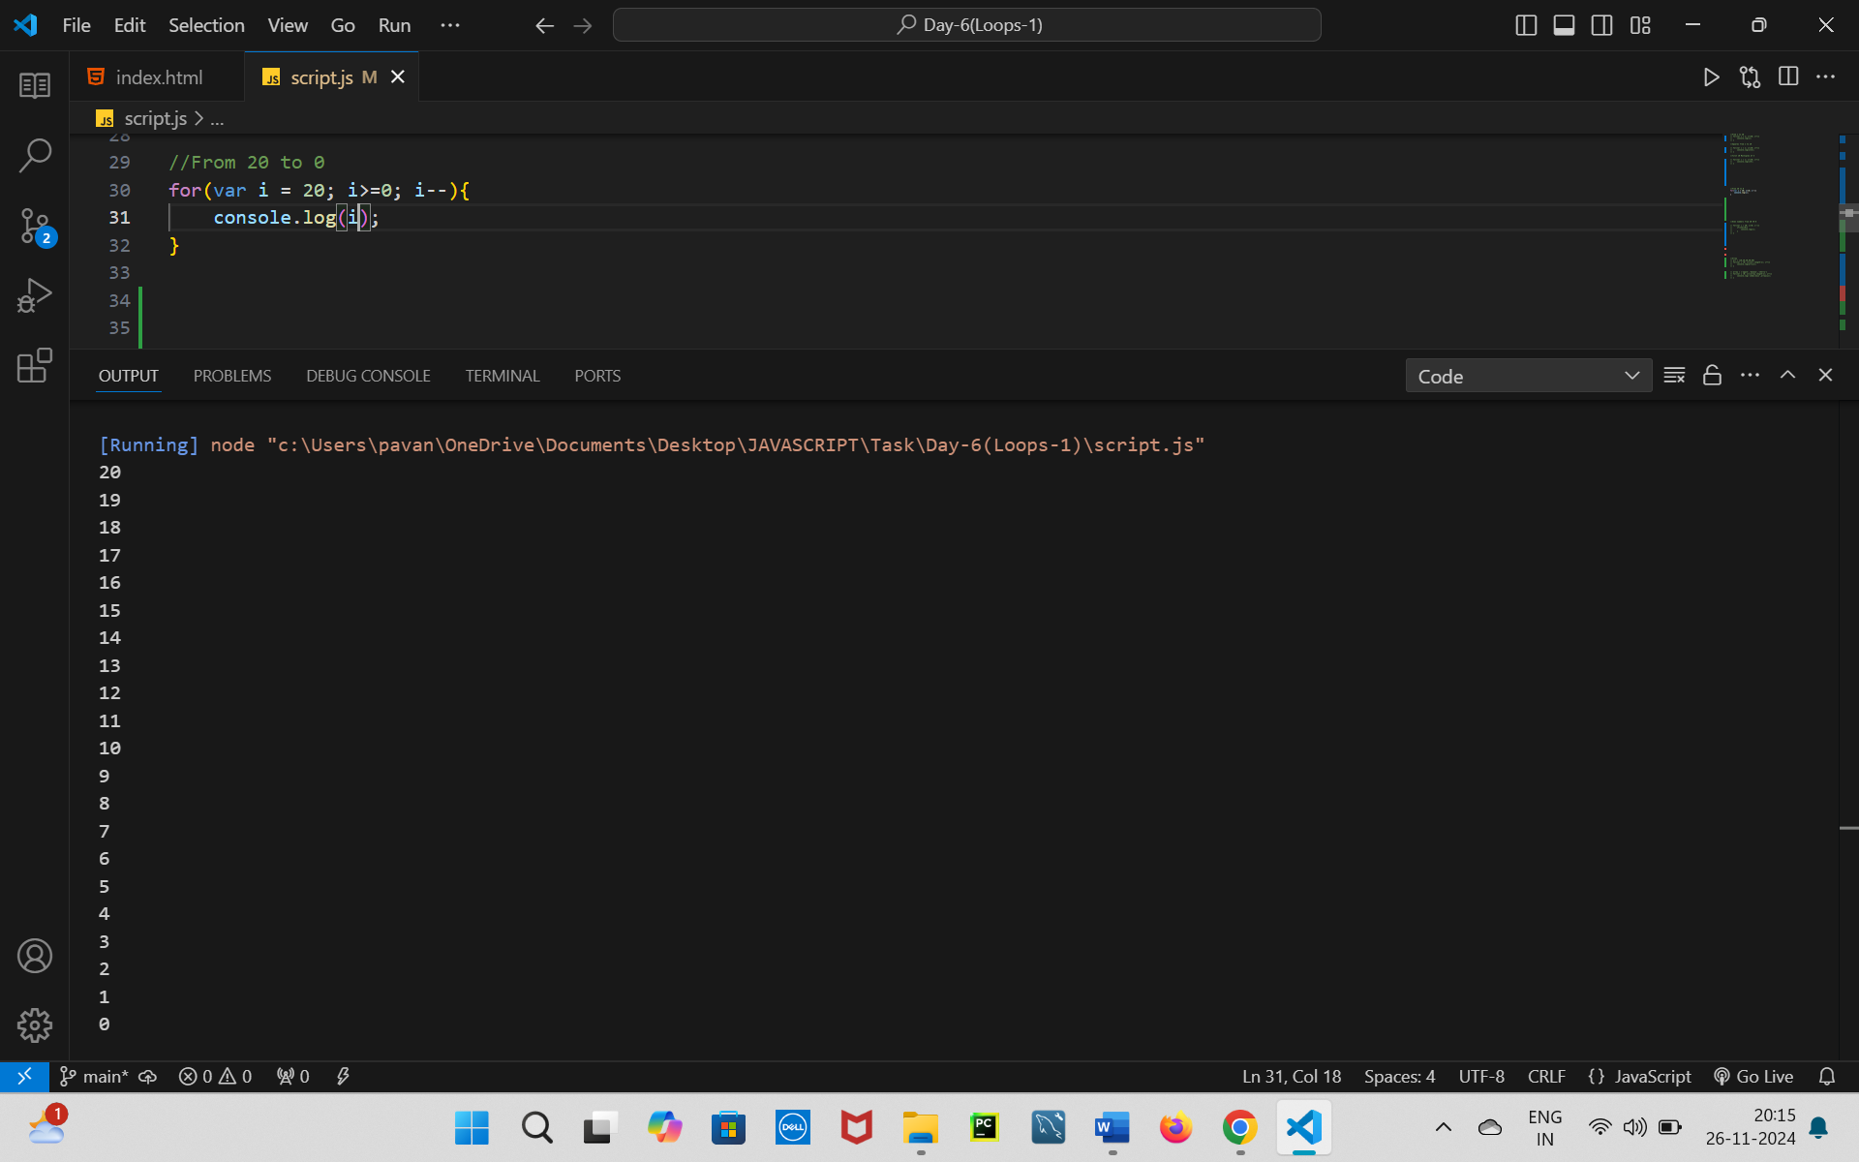

1. **Create a for loop to print the first 10 even numbers in reverse order (e.g., 20, 18, 16, …).**

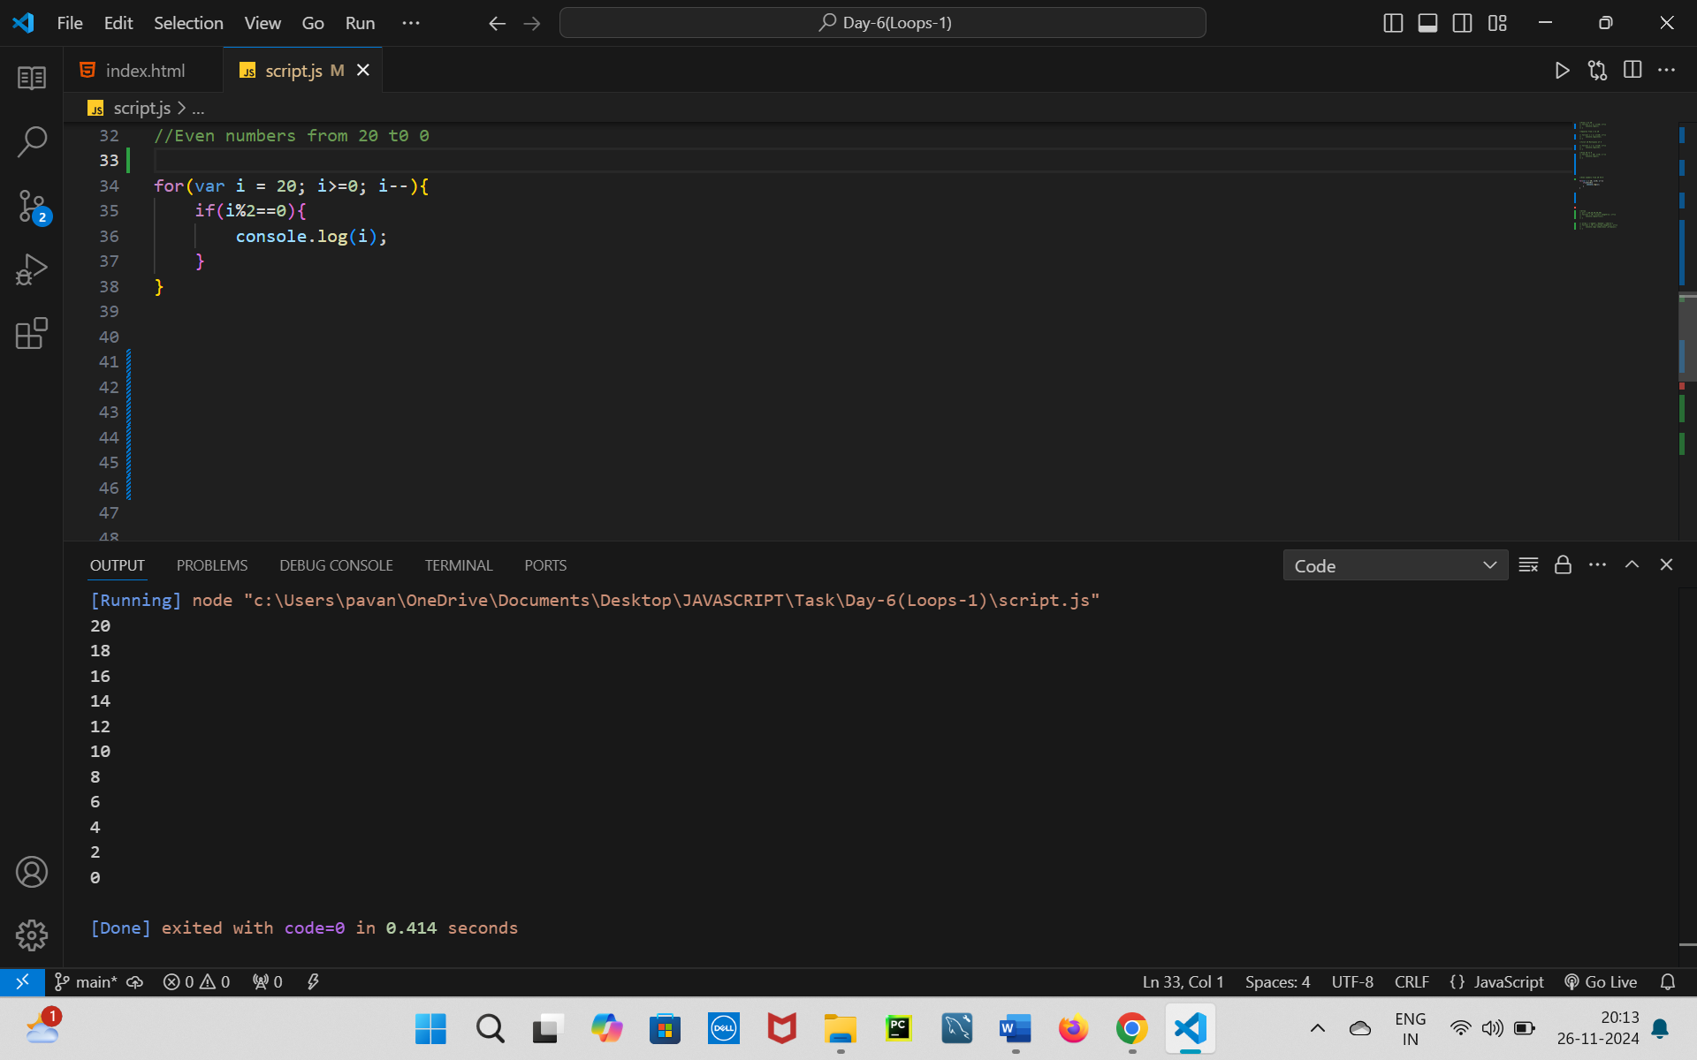

### Array

1. **Print each element of the array**
   * **Input:** [10, 20, 30, 40, 50]
   * **Expected Output:**
   * 10   
     20   
     30   
     40   
     50
   * 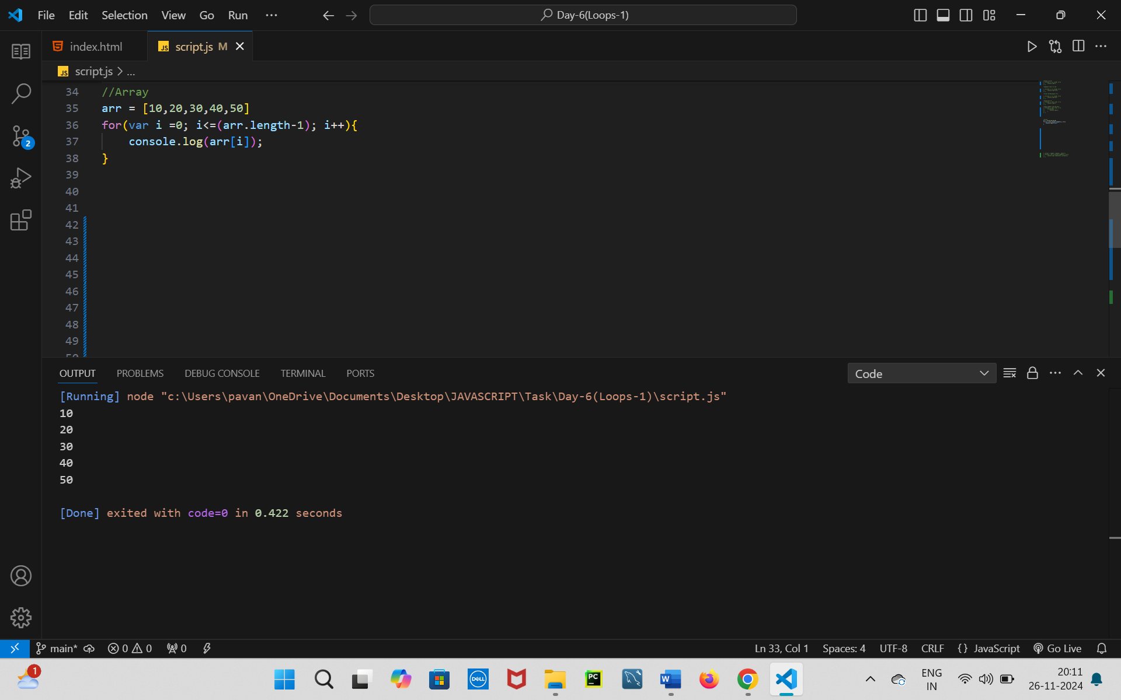
2. **Print the index of each element along with its value**
   * **Input:** ['apple', 'banana', 'cherry']
   * **Expected Output:**
   * Index 0: apple   
     Index 1: banana   
     Index 2: cherry

